SundayReview | Opinion

Amber Tamblyn: I’m Done With Not Being Believed
By AMBER TAMBLYNSEPT. 16, 2017
Photo
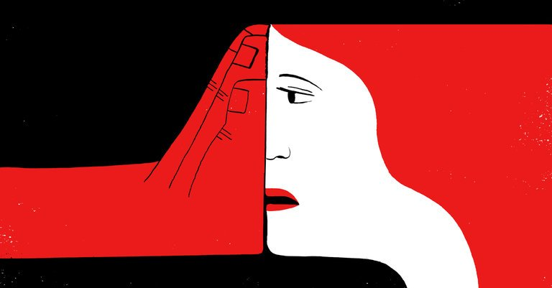
Credit Hanna Barczyk
When I was 21, I went into the office of a producer of the television show I was starring in to discuss a big problem. By this point I had been acting for more than a decade, and the show was very successful and beloved. Still, I was nervous about facing the firing squad of Emmys that sat behind him and saying what I had to say.
A crew member had kept showing up to my apartment after work unannounced, going into my trailer while I wasn’t in it, and staring daggers at me from across the set. I liked him at first. He was very sweet and kind in the beginning. We flirted a bit on set. But I was in a relationship. And liking someone certainly didn’t merit the kind of behavior he was exhibiting, which was making me feel unsafe.
My hands were freezing and I balled my wardrobe skirt up around my fists as I spoke. It was all caught in my throat — my embarrassment that it had gotten to this point. The producer listened. Then he said, “Well, there are two sides to every story.”
For women in America who come forward with stories of harassment, abuse and sexual assault, there are not two sides to every story, however noble that principle might seem. Women do not get to have a side. They get to have an interrogation. Too often, they are questioned mercilessly about whether their side is legitimate. Especially if that side happens to accuse a man of stature, then that woman has to consider the scrutiny and repercussions she’ll be subjected to by sharing her side.
Every day, women across the country consider the risks. That is our day job and our night shift. We have a diploma in risk consideration. Consider that skirt. Consider that dark alley. Consider questioning your boss. Consider what your daughter will think of you. Consider what your mother will think of what your daughter will think of you. Consider how it will be twisted and used against you in a court of law. Consider whether you did, perhaps, really ask for it. Consider your weight. Consider dieting. Consider agelessness. Consider silence.
It’s no wonder that the federal Bureau of Justice Statistics reported that from 2006 to 2010, 65 percent of sexual assaults went unreported. What’s the point, if you won’t be believed?
I use Twitter to follow the news, sigh with jealousy over posts from Beyoncé highlighting her gorgeous skin, and plug events I’m doing. On occasion, a comment will seem so misogynistic that I feel compelled to say something.
Photo
Amber Tamblyn, 2015. Credit John Lamparski/WireImage, via Getty Images
That happened this past week when a conversation about my friend Armie Hammer’s forthcoming film — in which a 24-year-old and 17-year-old have a relationship — escalated, as things can on Twitter, I guess, into a discussion with the actor James Woods about what is appropriate behavior in terms of an adult dating someone underage. Mr. Woods spoke critically, if flippantly, of the story depicted in the film. Mr. Woods has been known to date much younger women, so Armie pointed out the hypocrisy.
In an instant, I was reminded of a memory from when I was 16. Mr. Woods attempted to pick me and a friend up when we were at Mel’s diner in Hollywood, seeing if we wanted to go to Las Vegas with him that very night. I informed him of my age, to which he said, “Even better.” I told this story publicly as a way to back up the claim that Mr. Woods was, indeed, a hypocrite. Mr. Woods called my account a lie.
What would I get out of accusing this person of such an action, almost 20 years after the fact? Notoriety, power or respect? I am more than confident with my quota of all three. Even then, why would I choose the guy from “Scary Movie 2” to help my stature when I’m already married to the other guy from “Scary Movie 2”?
The emotional cost alone of bringing up such memories publicly or coming forward with such recollections is pure bankruptcy. It is spiritual foreclosure.
Mr. Woods’s accusation that I was lying sent me back to that day in that producer’s office, and back to all the days I’ve spent in the offices of men; of feeling unsure, uneasy, questioned and disbelieved, no matter the conversation.
I am part of a text chain of several incredible women — comedians, writers and actresses — that was formed after Election Day last year. We needed a space to vent, to cry, to dream about starting a commune with Hillary Clinton and anthropomorphizing Tom Hardy into a dreamy horse we could ride into the sunset. We needed a space to give one another supportive, strong advice.
One of the women on the chain talked about her fear of asking for the opportunity to direct. She said that she’d taken days to figure out exactly how she was going to ask for permission. Even after she got the directing gig, she was filled with anxiety that perhaps she wasn’t capable.
Disbelief is not just about men disbelieving us. It is about our own disbelief in ourselves.
I have been afraid of speaking out or asking things of men in positions of power for years. What I have experienced as an actress working in a business whose business is to objectify women is frightening. It is the deep end of a pool where I cannot swim. It is a famous man telling you that you are a liar for what you have remembered. For what you must have misremembered, unless you have proof.
The women I know, myself included, are done, though, playing the credentials game. We are learning that the more we open our mouths, the more we become a choir. And the more we are a choir, the more the tune is forced to change.
Amber Tamblyn (@ambertamblyn) is an actress, writer and director.
Follow The New York Times Opinion section on Facebook and Twitter (@NYTopinion), and sign up for the Opinion Today newsletter.

