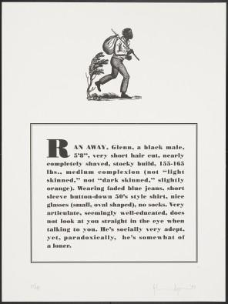
Curated Identity Triptych

curate: to pull together, sift through and organize for presentation

triptych: a work of art consisting of three panels, side by side

Glenn Ligon packaged his descriptions in the form of a “Ran Away” slave advertisement. Review the descriptions of you in your journal. If you choose, you may have a family member write a description of you to replace one of your descriptions in your journal.

Decide how to package the descriptions written about you by your classmates, for example, as an advertisement, album cover, movie poster, book cover, brochure, t-shirt, flag, map, song, rap, etc.

Use only one format.

Curated Identity Triptych

curate: to pull together, sift through and organize for presentation

triptych: a work of art consisting of three panels, side by side

Glenn Ligon packaged his descriptions in the form of a “Ran Away” slave advertisement. Review the descriptions of you in your journal. If you choose, you may have a family member write a description of you to replace one of your descriptions in your journal.

Decide how to package the descriptions written about you by your classmates, for example, as an advertisement, album cover, movie poster, book cover, brochure, t-shirt, flag, map, song, rap, etc.

Use only one format.

